CURRICULUM VITAE

JYOTIRMOY BHASKAR  Vill.- Bhadiswar, P.O.+P.S.- Murarai,  Dist.- Birbhum, West Bengal  Pin Code- 731219  Ph. No: +91-7501467457 (W.B)  +91-9700773657 (Hyderabad)  +91-7013804873 (Jio)  Email: sauravb.355@gmail.com  bhaskarjyotirmoy355@gmail.com
  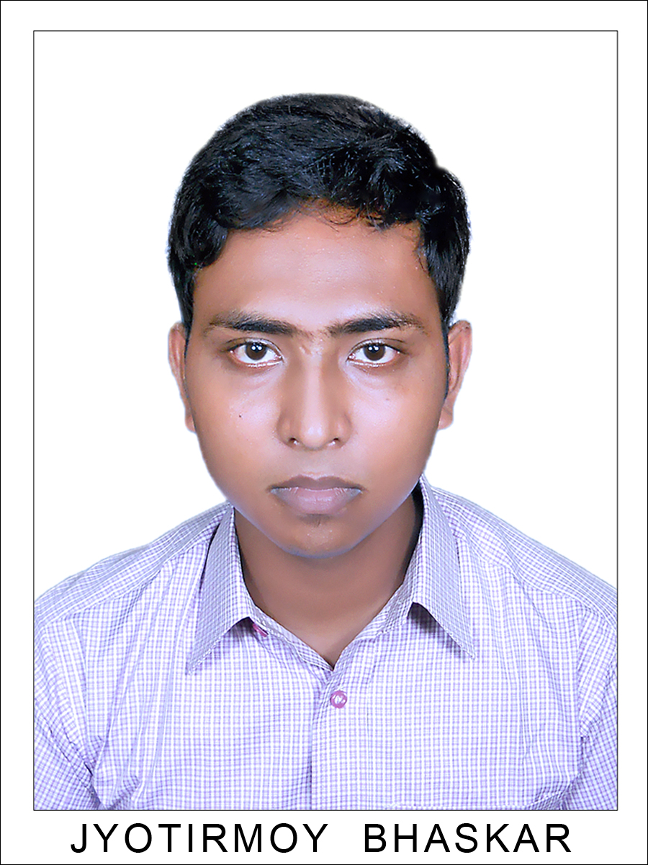

CAREER OBJECTIVE
I am looking forward to an opportunity where I can utilize my skills and abilities for the challenging job that offer professional growth.
ACADEMIC QUALIFICATION

Education 1: Masters of Business Administration (MBA) in Marketing
Board/University: Jawaharlal Nehru Technological University – Hyderabad
Progress: 2nd year, 4th sem Running…….

Education 2: Degree (B.A.) English Honours
Board/University: The University Of Burdwan, West Bengal
Year of Passing: 2014
Aggregate: 40.37%

Education 3: Class XII
Board/University: West Bengal Council of Higher Secondary Education
Year of Passing: 2010
Aggregate: 62.40%

Education 4: Class X
Board/University: West Bengal Board of Secondary Education
Year of Passing: 2008
Aggregate: 80.87%

COMPUTER PROFICIENCY
MS-Office (2003,2007,2010&2013), Dos, Internet, Formatting, Editing & Computer Servicing Software Applications etc.
WORK EXPERIENCE
- Marketing Executive in Paytm (Education) for Kolkata, Barasat, Kalyani, Howrah, Hoogly etc. (Experience: 3 Months Running)
- Admission Associate in Medak College of Engg. And Technology, Hyd. (Experience: 2 Years)
- Sales Executive in Inbourne Calls in PRISHA CALLTECH, Ameerpet, Hyd. (Experience : 1 Year)
- Data Entry Operator in RATION CARD DIZITIZATION OF INDIA, Murarai, W.B. (Experience : 2 Months)
PERSONAL SKILLS
- Comprehensive problem solving ability.
- Ability to deals with people diplomatically.
- Handling situations in critical period.
- Excellent client satisfaction and relationship.
ACHIEVEMENTS & ACTIVITIES
- Cricketer
- Badminton Player
- Volley Ball
PERSONAL DETAILS
Name: Jyotirmoy Bhaskar
D.O.B: 05.04.1993
Gender: Male
Father’s Name: Uttam Kumar Bhaskar
Nationality: Indian.
Language Known: English, Hindi & Bengali.
Hobbies: Playing Carrom, Cricket, Listing Music, Singing etc.
DECLARATION
I hereby declare that the above information is true to the best of my knowledge and belief.

Place: Murarai Sincerely
Date: ( Jyotirmoy Bhaskar)
Sign: __________________

